Homework-4

Natural convection, Boiling and Condensation

Due on: 26 th Mar 2020

**Exercise 1.** Steel (AISI 1010) plates of thickness *δ =* 6 mm and length *L* = 1 m on a side are conveyed from a heat treatment process (initial plate temperature of *Ti =* 300⁰C) and are concurrently cooled by atmospheric air at *T*α = 20⁰C.

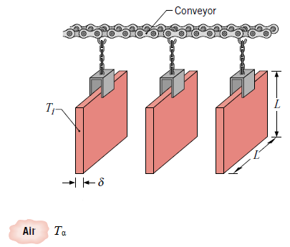

Consider the conveyor is not moving and the air is quiescent. Radiation effects and interactions between boundary layers on adjoining surfaces may be neglected.

(a) For the prescribed plate dimensions and initial temperature, as well as the prescribed air temperature, what is the initial rate of heat transfer from one of the plates?

(b) How long does it take for a plate to cool from 300⁰C to 100⁰C? Comment on the assumption of negligible radiation.

**Exercise 2.** Determine the maximum allowable uniform heat flux that may be imposed at a vertical wall heating panel 1 m high if the maximum temperature is not to exceed 37°C when the ambient air temperature is 25°C.

**Exercise 3.** Explain various phenomena that occur during saturated pool boiling. Use appropriate sketches.

**Exercise 4.** A nickel-coated heater element with a thickness of 15 mm and a thermal conductivity of 50 W/m K is exposed to saturated water at atmospheric pressure. A thermocouple is attached to the back surface, which is well insulated. Measurements at a particular operating condition yield an electrical power dissipation in the heater element of 6.950×107 W/m3 and a temperature of *To* = 266.4⁰C.

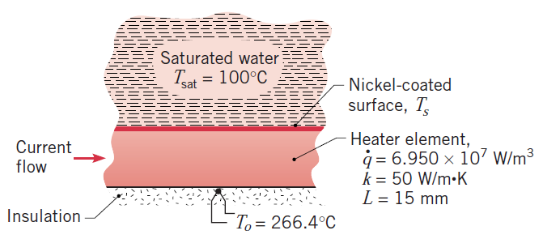

(a) From the foregoing data, calculate the surface temperature, *Ts*, and the heat flux at the exposed surface.

(b) Using the surface heat flux determined in part (a), estimate the surface temperature by applying an appropriate boiling correlation.

**Exercise 5.** Saturated steam at 1 atm condenses on the outer surface of a vertical, 100 mm diameter pipe 1 m long, having a uniform surface temperature of 94°C. Estimate the total condensation rate and the heat transfer rate to the pipe.

**Exercise 6.** Explain different conditions under which drop-wise or film type condensation may occur.